## **Dr.N.G.P. INSTITUE OF TECHNOLOGY**

**(An Autonomous Institution)**

**Approved by AICTE, New Delhi & Affiliated to Anna University, Chennai**

**Recognized by UGC & Accredited by NAAC with A+ & NBA**

**[BME, CSE, ECE, EEE and Mech]**

**DEPARTMENT OF ARTIFICIAL INTELLIGENCE AND DATA SCIENCE**

**MINI PROJECT**

# **On Bus Management System**

**Submitted by**

**PRAVEEN KUMAR S 710721243036**

**SANGAMESHWAR N OM 710721243041**

***in partial fulfilment of the requirements for the award of***

***the degree of***

**BACHELOR OF TECHNOLOGY**

**in**

**ARTIFICAL INTELLIGENCE AND DATA SCIENCE**

**Dr.N.G.P. INSTITUTE OF TECHNOLOGY**

**DEPARTMENT OF ARTIFICAL INTELLIGENCE AND DATA**  **SCIENCE**

**JANUARY 2024**

|  |  |  |
| --- | --- | --- |
| **S.NO** | **TABLE OF CONTENTS** | **PG.NO** |
| 1. | ABSTRACT | 02 |
| 2. | INTRODUCTION | 03 |
| 3. | KEY FEATURES | 04 |
| 4. | TECHNOLOGY USED & TECHNICAL STACK | 06 |
| 5. | UML DIAGRAM | 07 |
| 6. | MODULES | 08 |
| 7. | CONCLUISION | 09 |

**ABSTRACT**

The BUS Management System (BMS) is a web-based application designed to streamline and enhance the efficiency of managing transportation operations, and activities throughout the management portal . This system leverages HTML for the user interface and Java for backend functionality, providing a scalable and user-friendly solution for transportation-related tasks. BMS aims to automate and optimize various aspects of transportation management, including route planning, vehicle tracking, and resource allocation.

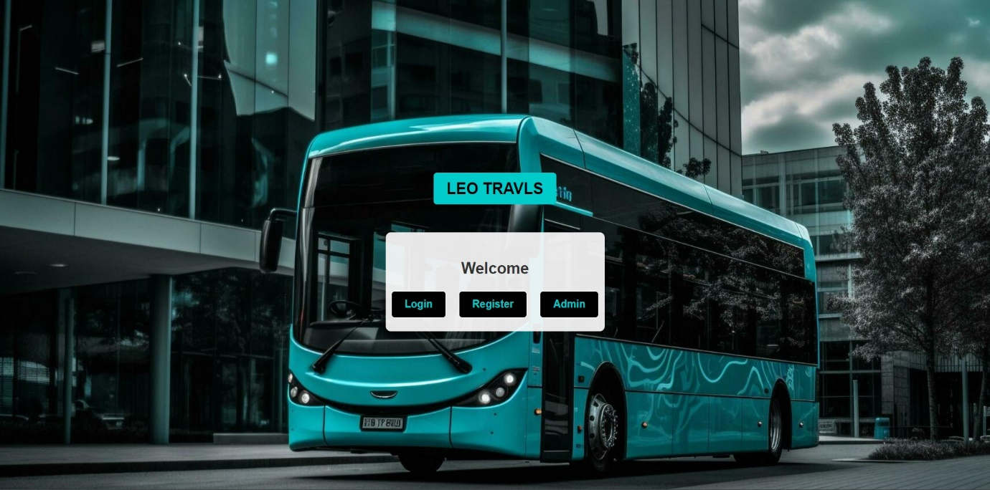

**INTRODUCTION**

In the rapidly evolving landscape of urban mobility and transportation, efficient and effective management of bus services is crucial for ensuring seamless transit operations. The Bus Management System (BMS) emerges as a comprehensive solution designed to address the complexities associated with the administration, monitoring, and optimization of bus transportation services. Leveraging cutting-edge technologies, BMS integrates user-friendly interfaces and robust backend functionalities to streamline the entire spectrum of bus transport management.

The demand for reliable and punctual public transportation services has grown significantly with the expanding urban population. Managing a fleet of buses, routes, schedules, and personnel while meeting the expectations of passengers for timely and convenient services presents a formidable challenge. The BTMS is envisioned as a tool to empower transportation authorities, fleet operators, and passengers alike with innovative features to enhance the efficiency, safety, and overall experience of bus transportation.

**KEY FEATURES**

**Enhanced Operational Efficiency:** BTMS aims to optimize the daily operations of bus services by automating key processes such as route planning, scheduling, and resource allocation. This efficiency translates into improved on-time performance and better utilization of available resources.

**Real-Time Monitoring and Tracking:** With advanced GPS technology and real-time tracking features, BTMS provides administrators with a live overview of the entire bus fleet. This enables effective monitoring, allowing for quick response to incidents, better traffic management, and enhanced security for both passengers and assets.

**Improved Passenger Experience:** BMS focuses on elevating the passenger experience through features such as accurate and real-time bus arrival information, user-friendly ticketing systems, and communication channels for service updates. This contributes to increased rider satisfaction and encourages public transportation usage.

**Data-Driven Decision Making:** The system collects and analyses data related to bus performance, ridership patterns, and maintenance needs. This wealth of information empowers decision-makers to make informed choices, optimize routes, and plan for future infrastructure improvements.

**Cost Optimization:** BMS helps control operational costs through intelligent resource allocation, fuel efficiency analysis, and proactive maintenance scheduling. By identifying areas of improvement, transportation authorities can make cost-effective decisions to maximize the return on investment.

**Adaptability and Scalability:** Recognizing the dynamic nature of transportation systems, BMS is designed to be adaptable and scalable. It accommodates changes in route configurations, fleet sizes, and operational requirements, ensuring its relevance and effectiveness as the transportation landscape evolves.

**TECHNOLOGY USED**

• Frontend: HTML.

• Backend: Java Servlets for handling user requests and database interactions.

• Database: Relational database MySQL to store transport and route data.

• Development Tools: Java IDE Eclipse.

**TECHNOLOGY STACK**

1. Java:

- Leveraging the power of Java for backend development, ensuring robustness, scalability, and compatibility across different platforms.

2. HTML:

- Employing HTML for creating a dynamic and responsive user interface, providing an engaging experience for users accessing the system from various devices.

3.Servlet:

- Utilizing servlet technology to handle requests and responses, enabling seamless communication between the frontend and backend components of the system.

**UML DIAGRAM**

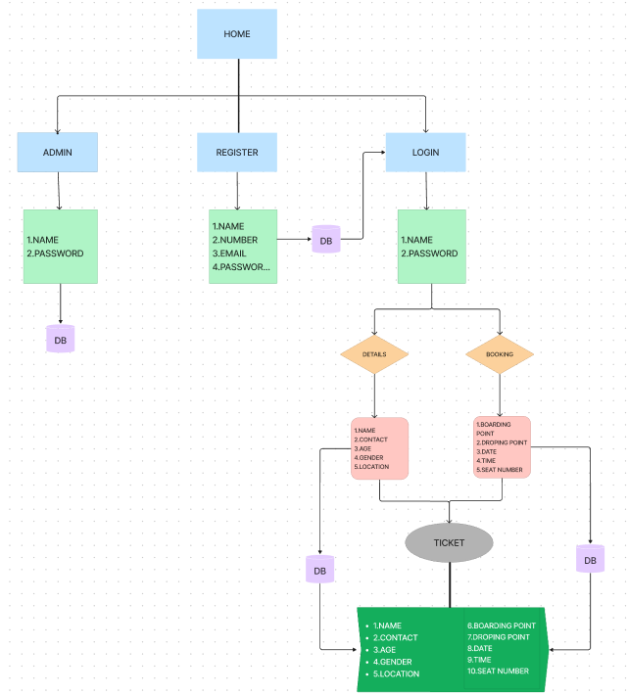

**MODULES**

1.ADMIN

2.REGISTRATION

3.LOGIN

**ADMIN**:

Collect the admistrator details through which the admin could inspect and observe the number of people registered and the number of tickets booked for the bus and for the route respectively.

**REGISTRATI0N**:

It allows user to register into the portal collecting their details and hence using their registered user name and password they could access the ticket booking portal.

**LOGIN**:

Through the login module the user could enter the portal and continue with their ticket booking, ticket verifying, transport tracking and monitoring and ticket cancellation.

**CONCLUSION**

In conclusion, the Bus Transport Management System represents a pivotal step towards modernizing and optimizing bus transportation services. By incorporating advanced technologies and addressing the diverse needs of transportation stakeholders, BMS seeks to revolutionize how bus services are managed, ensuring a reliable, efficient, and passenger-centric public transportation experience.